**Properly configure the VLAN for guest and video connections to meet the project requirements. Submit a screenshot of the VLAN table. [CYB-210-01]**

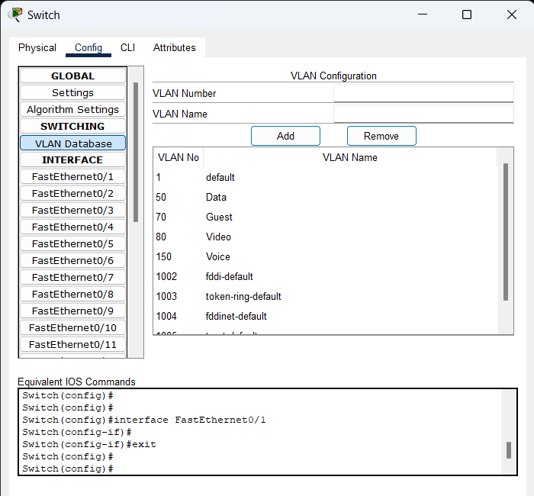

**Properly configure the guest wireless network to meet the project requirements. Submit a screenshot of the wireless settings for the wireless router. [CYB-210-03]**

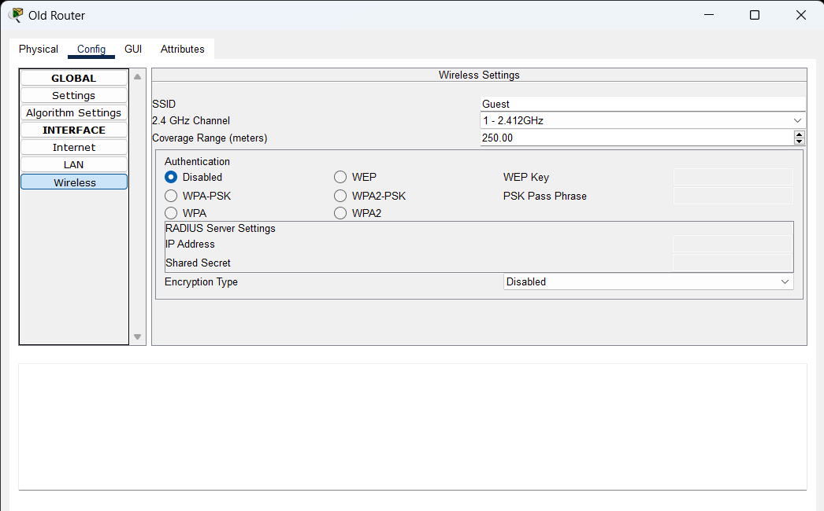

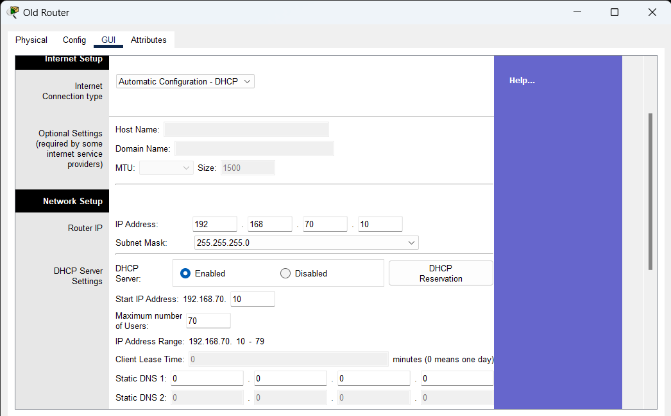

**Make sure that devices are connected to the guest wireless network to meet the project requirements. IP addresses for the devices should be noted in the network diagram PNG or PDF. [CYB-210-03]**

**Make sure that cameras are connected to the video network to meet the project requirements. IP addresses for the cameras should be noted in the network diagram PNG or PDF. [CYB-210-03]**

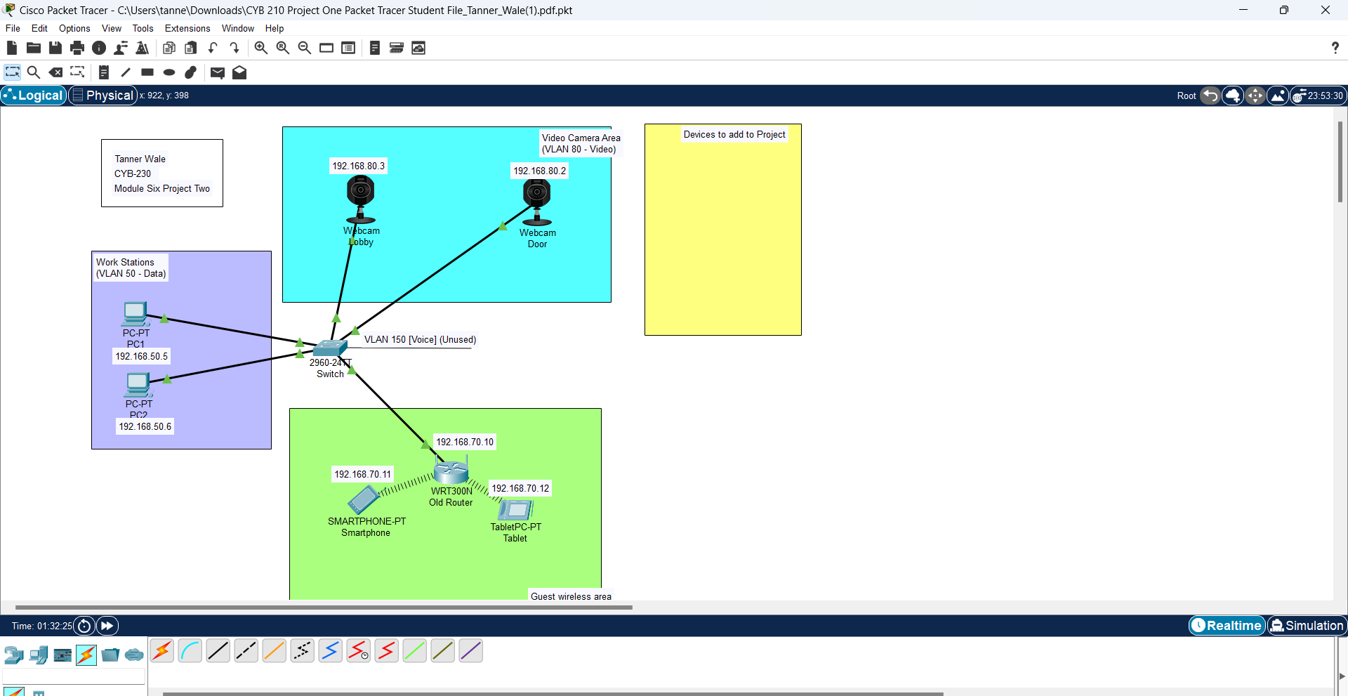

**Make sure that guest and video networks are properly segmented. Submit screenshots of ping tests that prove you have met this project requirement. [CYB-210-01]**

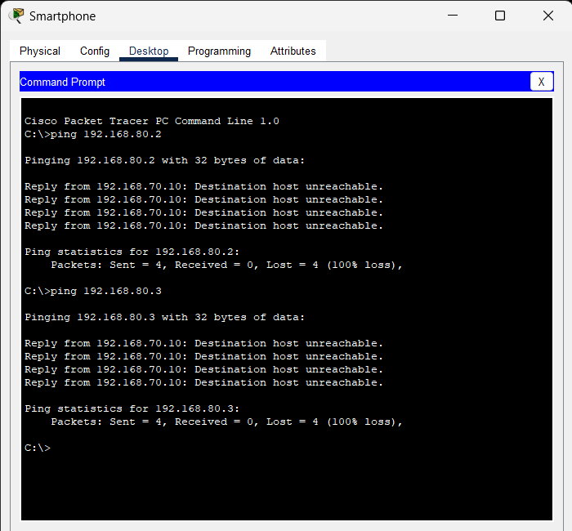

**Describe how you segmented network traffic to meet the project requirements for guest and video connections. [CYB-210-01]**

I segmented the network traffic by having different VLANs for different groups on the network. The first group is the Guest network that has a default gateway of 192.168.70.10. This group has up to 70 IP address pool assigned at a single time but no more than that. This is because we dynamically assigned these IP addresses to anyone who wants to connect to the SSID. The VLAN for this group is VLAN 70 called Guest. The next group is the video network for the door and lobby. These devices are on the default gateway 192.168.80.1. These devices are statically assigned to the network for monitoring purposes. This network is on VLAN 80 called Video. These networks cannot communicate with each other as they are in a different subnet and default gateway. Nobody from the Guest network can communicate with the Video network. If communication is needed, they must disconnect from the Guest network and connect to the Video network. The switch on the network will only route traffic to the Guest network if the VLAN destination is VLAN 70, this is the same for the Video network as the VLAN must be 80 for it to route traffic to that subnet. This divides the traffic on the network.

**Explain how you considered the scalability of the guest wireless network in order to meet the project requirements (IP addressing, leasing, etc.). [CYB-210-01]**

The scalability of the Guest network was done by giving the IP address pool 70 IP addresses to dynamically assign with a lease time. If we ever needed to increase the size of the network or the company wanted to increase its scale of people, they could provide internet access to at once we would just increase the IP address pool size. By doing this the lease time may need to be cut in half because more people are connecting to the network. Having faster release of IP addresses will help business operations function without having to worry about DHCP scope exhaustion. DHCP scope exhaustion is when new clients try to connect to your network, but they are denied because the DHCP has no more IP addresses to hand out (Balsimo, 2018). Also, another solution to help the network could be to implement another router to divide the traffic to the guest network giving faster internet speeds to Guest on your network.

**References**

Balsimo, T. (2018, November 15). Turn Windows DHCP Server logs into actionable metrics using Amazon Kinesis Agent for Windows | AWS Big Data Blog. Aws.amazon.com. <https://aws.amazon.com/blogs/big-data/turn-windows-dhcp-server-logs-into-actionable-metrics-using-amazon-kinesis-agent-for-windows/#:~:text=When%20%E2%80%9Cscope%20exhaustion%E2%80%9D%20occurs%2C%20any%20new%20clients%20are>